WEEK 1

HANDS-ON EXERCISES

**Exercise 1: Implementing the Singleton Pattern**

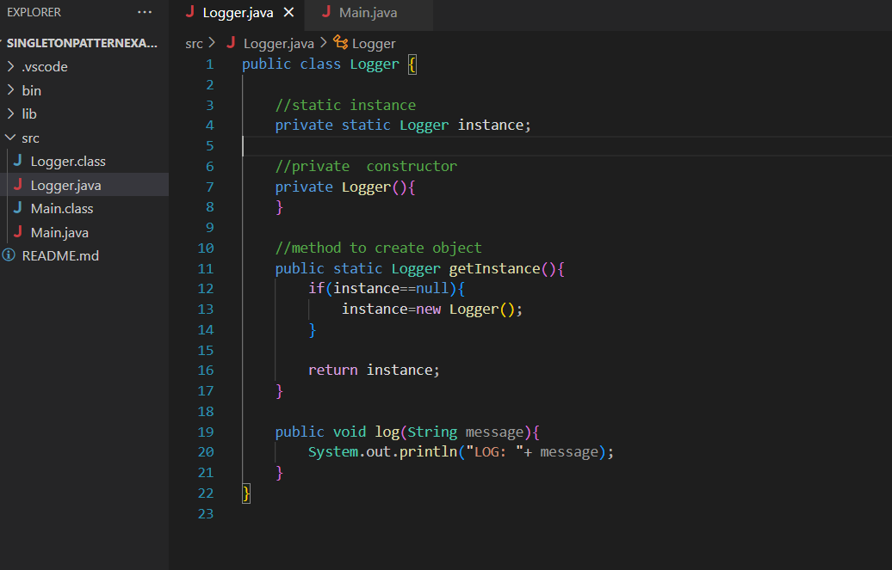

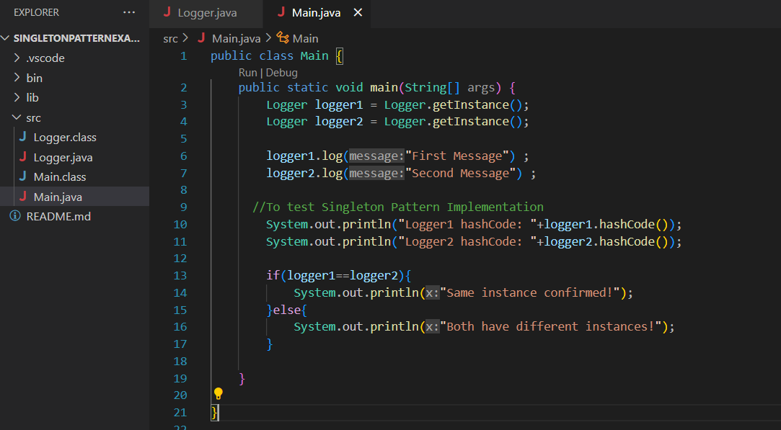

Output:

